**Background**

In the modern banking industry, customer retention is critical for long-term success. With rising competition and increased customer expectations, banks face the constant challenge of maintaining their customer base. Customer churn—when a customer stops using a bank’s services—is a major concern, as acquiring new customers is often more expensive than retaining existing ones.

Banks collect a wealth of data about their customers, including demographics, account activity, and financial behavior. Leveraging this data through analytics and machine learning can help predict which customers are most likely to churn, allowing the bank to take proactive steps to retain them.

**Problem statement**

The objective of this analysis is to identify the key factors that influence customer churn in a retail banking environment. Using historical data of customer attributes and activity, the goal is to:

Understand the demographic and behavioral patterns of customers who have exited.

Visualize trends and insights related to churn.

Identify actionable variables that can help predict churn.

Provide insights that can support targeted retention strategies.

**BUSINESS QUESTIONS**

1. Which country has the highest active and exited customers
2. How does the age of the customers affect the churn rate
3. Is there a correlation between the credit scores and the churn rate?
4. How does the credit scores vary across the different countries?

**METHODOLOGY**

**Data Cleaning:**

Remove duplicates: using the remove duplicate function one the data ribbon. No duplicate row was found.

Groupings: some columns needed to be grouped to aid in analyzing the data. They include:

Age – Age group

Tenure – Tenure groups

Credit score – credit category

Each grouping was done in a new column beside the original

Removing the string “NO”: ‘NO’ was removed from the active members and exited members column, to ensure the only the active members and the exited members would be counted.

**Exploratory data analysis**

The dataset contains:

* + 10,000 rows excluding the headers, each row representing a customer
  + 16 columns
  + The total customers of 10,000, 5,234 active customers, 2,166 exited customers, and an average credit score of 651

**Analysis**

Questions:

1. Which companies has the highest and lowest ESG scores**?**

**Approach**: Created two pivot tables showing the top 3 performing companies and the least performing companies based on their ESG Overall Score. Created a column chart to illustrate them.

**Finding**: Company 478, 472, and 353 were the highest performing companies while company 84, 302, 311 were the lowest performing companies.

1. Which ESG pillars exhibit the strongest correlation with financial performance?

**Approach**: Calculated the correlation of the ESG pillars with the profit margin using the CORREL function and used a pivot bar chart to visualize it.

**Finding**: ESG Environmental had the strongest correlation with both the Profit Margin (0.22).

1. Which industries have the highest ESG score?

**Approach**: Created a pivot table with the industries and Overall ESG Score. A bar chart was used to illustrate it.

**Finding**: Finance had the highest ESG Score Followed by Technology, Transport had the lowest score

1. How does the ESG pillars vary across different geographical regions?

**Approach**: Created a pivot table containing different Regions and the ESG Pillars (Environmental Social, and Government). A clustered column was used to illustrate it.

**Finding**: Europe had the highest Social and Government Scores for the regions while middle east had the lowest of both scores. Environmental Scores had little variations across the regions with the highest being Latin America and lowest North America.

1. How do key financial performance indicators differ across various industries and different geographical regions?

**Approach**: Created 2 pivot table showing the different average growth rate and profit margin by industries and regions respectively. A clustered column was used to illustrate it.

**Finding**: the top performing industries were Technology and healthcare while for the regions there was little variations with Africa having the highest Profit Margin while Latin and North America having the highest Growth rate

**RESULTS**

**Company Performance Analysis**

* Top Performers: Companies 478, 472, and 353 demonstrated exceptional ESG Scores
* Underperformers: Companies 84, 302, 311 had the least ESG Score

**ESG Correlations**

Environmental ESG factors showed the strongest positive correlation with financial metrics:

* 0.22 correlation with Profit Margin

**Regional Variations**

* Europe: Led in both social and governance scores but had the least profit margin
* Latin America: had the highest environmental score as well as the highest growth rate for the regions

**Industry Performance**

* Technology: had the highest profit margin and growth rate for the industries, it was also had the second best ESG Overall Score.
* Healthcare: Showed balanced excellence with top Growth rate (17.86%) and highest Profit Margin (17.15%)
* Finance: which had the best ESG Overall Score came 3rd and 4th for Profit Margin and Growth Rate respectively

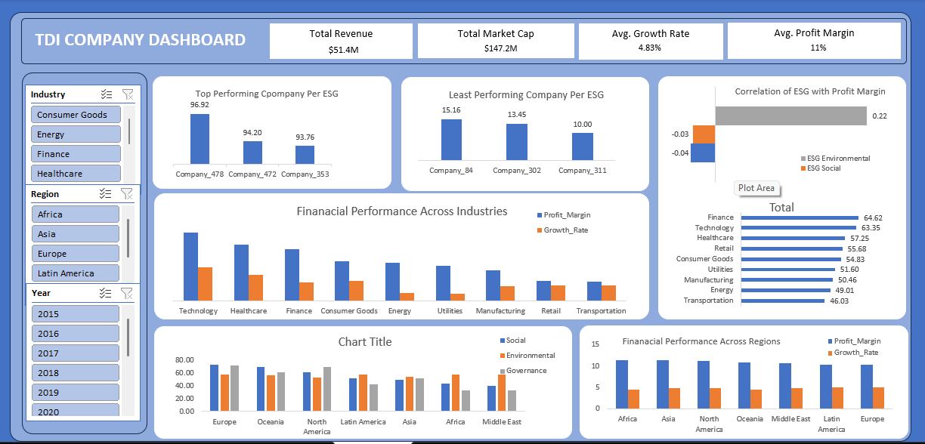

**DISCUSSION**

The results of our analysis reveal several important trends and correlations that deserve further interpretation.

**High and Low Performers:** Companies 478, 472, and 353 emerged as top performers in ESG scoring, suggesting strong sustainable practices, while companies 84, 302, and 311 were identified as areas needing substantial improvement

**ESG and Financial Performance Correlation:**

Among the three ESG pillars, Environmental factors exhibited the strongest positive correlation with Profit Margin (0.22). This suggests that companies prioritizing environmental sustainability may be experiencing tangible financial benefits. This correlation, while moderate, indicates that environmental initiatives may be translating to improved financial outcomes, either through operational efficiencies, market differentiation, or consumer preference.

**Regional Performance Variation:**

Europe consistently outperformed other regions in **Social** and **Governance** pillars. This reflects Europe's strong regulatory frameworks (such as the European Green Deal and SFDR regulations) and societal emphasis on corporate responsibility, diversity, and ethical governance. However, despite their high ESG standards, European companies recorded **lower Profit Margins** compared to other regions, suggesting that the high cost of compliance, investments in sustainability, and mature market competition might impact short-term profitability.

LatinAmerica stood out with the **highest Environmental Score** and the **highest Growth Rate** among regions. This points to a growing focus on environmental stewardship in Latin America, possibly fueled by external investment pressures, local government initiatives to protect biodiversity, and the economic opportunities associated with sustainable development projects. The strong growth rate also suggests that companies in this region are successfully capturing emerging market opportunities tied to ESG innovation.

Africa reported the **highest Profit Margin** regionally, despite not leading in ESG scores. This could reflect high margins in specific industries such as natural resources and commodities, where ESG adoption is still maturing. As ESG adoption deepens, African companies could enhance their long-term competitiveness even further.

Middle East exhibited the **lowest Social and Governance scores**, indicating a need for stronger focus on human rights, labor practices, diversity, and corporate governance improvements. However, given ongoing diversification efforts (e.g., Vision 2030 initiatives in countries like Saudi Arabia), there is potential for significant future improvements.

North America showed **lower Environmental Scores** compared to other regions, suggesting slower adoption of certain environmental practices relative to European and Latin American counterparts. However, North America remained competitive in terms of Growth Rates, highlighting opportunities to strengthen ESG without compromising financial momentum.

**Industry Performance:**

Finance emerged as the leading industry in terms of ESG Overall Score. This indicates a strong emphasis on environmental stewardship, social responsibility, and governance standards within the financial sector. Financial institutions, driven by regulatory pressures and investor expectations, have increasingly prioritized sustainability reporting, responsible investment practices, and risk management strategies related to ESG factors.

Technology ranked second in ESG performance but distinguished itself as the industry with the **highest Profit Margin and Growth Rate**. This suggests that companies in the technology sector are successfully integrating sustainable practices without sacrificing financial performance — and, in fact, potentially enhancing it. Rapid innovation, scalable business models, and a growing emphasis on green technologies (e.g., energy-efficient data centers, responsible sourcing of materials) may partly explain this dual success.

Healthcare demonstrated a well-rounded performance, achieving the **highest Profit Margin (17.15%)** and a **top Growth Rate (17.86%)**, alongside strong ESG standings. This reflects the sector’s critical societal role and its growing focus on sustainable healthcare delivery, ethical practices in clinical trials, and access to care initiatives. The combination of financial and ESG success highlights healthcare's strategic positioning for long-term resilience

.

**CONCLUSION**

The analysis clearly shows that strong ESG practices are increasingly aligned with better financial outcomes, although the relationship varies by industry and region.

At the **industry level**, Finance led in ESG performance, driven by regulatory compliance and growing investor scrutiny. Technology and Healthcare industries demonstrated a balance between strong ESG scores and outstanding financial performance, indicating that sustainability and profitability can reinforce each other. Conversely, industries like Transport, with lower ESG scores, may face higher risks and growing pressures to improve their sustainability practices.

At the **regional level**, Europe stood out for its leadership in Social and Governance aspects, reflecting advanced regulatory environments and societal expectations. However, this high ESG performance did not necessarily translate into the highest financial returns, showing that sustainable practices often involve longer-term investments. Latin America emerged as a region of dynamic growth with notable Environmental improvements, while Africa, despite lower ESG scores, showcased strong profitability. Meanwhile, North America and the Middle East displayed areas where significant ESG advancements are still needed, particularly regarding environmental practices and social/governance structures respectively.

Overall, the findings highlight that industries and regions investing strategically in ESG are positioning themselves for sustainable growth, risk mitigation, and enhanced stakeholder trust.

**RECOMMENDATIONS**

**1. Strengthen Environmental Initiatives:**Given the positive correlation between environmental practices and profit margins, companies — especially those in Transport and North America — should prioritize environmental improvements such as reducing carbon footprints, adopting renewable energy, and promoting eco-innovation.

**2. Industry-Specific ESG Strategies:**Industries like Transport and sectors in emerging markets should develop tailored ESG roadmaps. This could include sector-specific initiatives like green logistics for Transport or ethical sourcing in Healthcare and Technology.

**3. Regional Customization of ESG Efforts:**Regions like the Middle East and North America should intensify efforts on social responsibility and governance structures to match global best practices. Policies fostering employee well-being, diversity, transparency, and ethical leadership should be emphasized.

**4. Focus on Long-Term Value Creation:**Companies, particularly in Europe, should communicate to investors that strong ESG performance may involve higher upfront costs but ultimately leads to long-term value creation, lower risk exposure, and stronger brand loyalty.

**5. Leverage Data-Driven ESG Management:**Implement comprehensive dashboards to monitor ESG and financial performance together, allowing companies to quickly identify gaps and opportunities for improvement. Regular, transparent reporting will also build stronger trust with investors and stakeholders.

**6. Encourage Cross-Regional Best Practice Sharing:**Organizations should foster global collaboration by sharing successful ESG strategies across regions. For example, Europe’s strong social and governance frameworks can guide improvements in the Middle East, while Latin America’s environmental momentum can inspire North America and Africa.